Electronic Grade Change

1. Click the *Grade Roster* button.



1. Select *Request Grade Change* button.

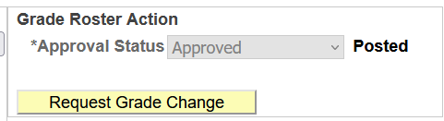

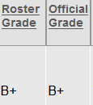

1. Select student grade to be changed. Select new grade from the drop-down menu and click Submit. Process will verify the change was successful.

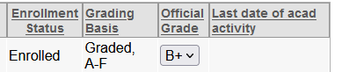

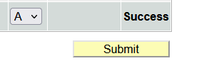

1. Roster now shows new grade in Official Grade Column.

